The Secret Life of the Genome: Repair of DNA base modifications

Sheila S. David
Department of Chemistry, University of California, Davis, California 95616, United States
ssdavid@ucdavis.edu

The DNA bases hold the informational content of DNA. Modified DNA bases are considered “DNA damage” and have the potential to alter the coding properties and cause deleterious DNA mutations. There is also a growing appreciation that DNA base modifications may influence a broad range of cellular processes beyond mediating permanent DNA mutations. DNA glycosylases play a key role in removing damaged DNA bases as an initiating step in base excision repair (BER). We have focused extensively on the repair of oxidized guanines, and the BER glycosylases MUTYH and NEIL1. MUTYH is the human homolog of MutY and is a [4Fe-4S] cluster glycosylase that targets removal of an undamaged adenine from 8-oxoguanine (OG):A mismatches. In contrast, NEIL1 removes a broad range of oxidized guanine lesions, as well as oxidized pyrimidines, and also is capable of removing lesions in a wide variety of contexts including ssDNA and G-quadruplexes. Using a multi-pronged approach including enzyme kinetics, structural studies and cellular assays, we have revealed key features involved in the recognition and base excision activity of these two distinct glycosylases. For example, we have recently revealed that the 2-amino group of OG is a key feature for the initial detection of OG:A over T:A base pairs. My laboratory also played an important role in the discovery of MUTYH-associated polyposis (MAP), an inherited form of colorectal cancer, by revealing that the two most common MAP variants have a hampered ability to recognize OG. We have continued to reveal interesting features of MAP variants, and the location and dysfunction of disease-associated variants has provided a window for revealing new features of MUTYH. We also have shown that the hydantoin lesions Gh and Sp are the best-documented substrates for NEIL1. In addition, we uncovered that there are two forms of the NEIL1 glycosylase resulting from mRNA editing (recoding) that have distinct differences in enzymatic processing of DNA base lesions. More recently, we have revealed features of the repair that are unique to a given NEIL1 substrate and the consequences of NEIL1 recoding. Comparing and contrasting the two glycosylases illustrates the “fine-tuning” provided by DNA repair glycosylases to detect, mediate and respond to DNA base modifications.

Biography:
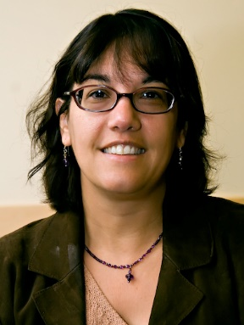
Sheila David received her Ph.D. from the University of Minnesota in 1989. She was an NIH Postdoctoral Fellow from 1990-1992 at the California Institute of Technology. She became an assistant professor at the University of California, Santa Cruz in Fall of 1992, and then subsequently moved to the University of Utah in 1996, where she rose through the ranks to Full Professor in 2002. In 2006, she joined the Chemistry Department, University of California, Davis. She has received several prestigious awards, including a UCD ADVANCE Scholar Award for excellence in research and mentoring, ACS Fellow in 2011, AAAS Fellow in 2010, A. P. Sloan Research Fellow Award for 1998-2002, Arnold and Mable Beckman Young Investigator Award (1992-1994). She serves on editorial advisory boards for DNA repair, (2005-Present) and Cell Chemical Biology. (2015-present). Her research focuses on using chemical biology approaches to study DNA repair.

